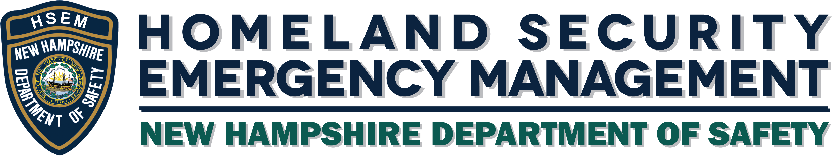

Local Distribution Management Plan Guidance

8/24/2020

[This Page Intentionally Left Blank]

# Purpose

This guide is to assist local communities and agencies to create their own Distribution Management Plan that adequately describes how food, water, fuel, medication, and other emergency essential supplies will be delivered to their community’s residents when normal supply chains are broken.

Recent events have impacted supply chains unexpectedly, such as the increased protective measures and lack of personnel due to quarantine or sickness. Therefore, it is important for each community to develop a comprehensive and flexible plan for how emergency essential supplies will obtained and distributed to the impacted residents.

The supply chain may be impacted in an acute timeframe for a specific commodity, or over a longer time period, touching multiple areas of concern.

The State of New Hampshire is developing a statewide distribution management plan to get materials out at the state level, but each community will need to address its specific needs or limitations. This guide will assist you in developing a plan that will enable your community to minimize the impact of a supply chain disruption and enable basic supplies to be made available to residents in need.

Resources should also include response personnel and equipment, such as medical professionals, search and rescue, delivery, warehousing, sheltering, etc.; and equipment such as generators, personal protective equipment, and equipment unique to the situation.

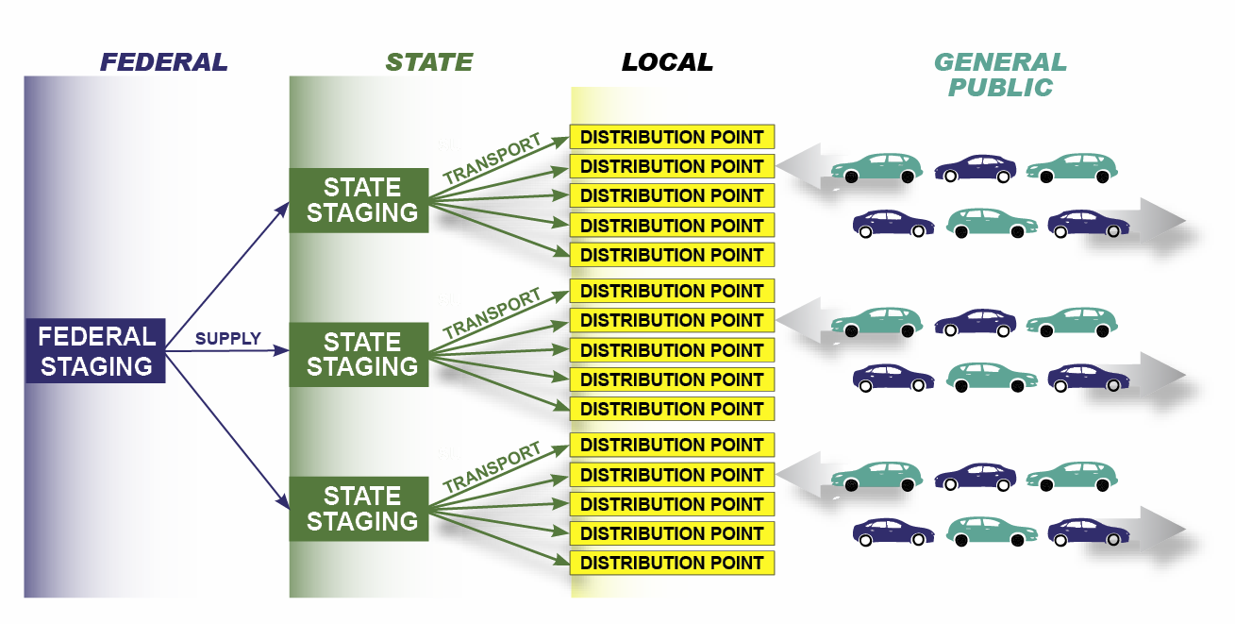

# Key Elements of a Distribution Management Plan

A well-developed plan needs to answer the following questions:

* What is needed?
* How much of it is needed?
* Where should it be?
* When and how should it be transported?
* Who is responsible for custody and distribution?

## What is needed?

* You can anticipate what types of resources will be needed by using records and lessons learned from past events that have happened to your community or to the other communities similar to yours,
* Other tools you could use to help you figure what will be needed are:
  + The Threat and Hazard Identification and Risk Assessment (THIRA) which helps in understanding the risks to a community and how to determine the types of resources needed to address the risks.
  + The Hazard Identification and Risk Assessment (HIRA) identifies the risks, profiles potential hazard events, provides an inventory of assets available, and the estimation of possible human and economic losses based on the vulnerability of the community.
* Common types of emergency essential resources are meals, water, fuel, and mass care supplies which include medications, medical equipment, sheltering, personal protective equipment, and other incident-specific emergency supplies.
* Don’t forget to include the needs of livestock and pets within your community. In the case of an evacuation, many residents who own animals will be very reluctant to leave their animals behind so you may need to have a plan for providing animal feed and medication to those residents who stay behind or cannot leave their homes.
* Consider your special needs populations such as the long-term care facilities, mental health facilities, and home-bound residents as they may require direct or home deliveries.
* Don’t forget about your residents who may not speak or understand English well. These people may not be able to understand emergency notifications or guidance that is put out as to where to go for food, shelter, water, and other needs.

## How much is needed?

How much of the different types of resources will be determined by the type and severity of the event, but a good estimate would be to plan for about 3 days’ worth of emergency supplies on hand for your community or as possible depending on storage availability. For example, the American Red Cross and the State of New Hampshire plans for two meals and three liters of water per person per day.

When you are determining how much is needed, consider the anticipated restoration of private sector supply chains and how this will impact the time period that critical emergency supplies are needed. Monitor the private sector’s ability to reestablish its supply chain, which may reduce the need for emergency commodities and resources. Involve the private sector with the response (e.g., transportation, supplies, food, water, and third-party logistics such as warehouse management or inventory tracking).

* Partnership Considerations
  + Consider mutual aid agreements with neighboring communities and agencies when figuring out how much is needed.
* Contracting Considerations
  + Legislation
    - Pay attention to applicable procurement laws and regulations when setting up contracts with private vendors.
    - Have a statement of work already developed for last-minute resources so that you can move quickly on a new contract.
  + Existing Contracts
    - Conduct an inventory of all existing contracts prior to an incident
    - Adding an estimated capacity to an existing contract could speed up the ordering process during a time crunch
  + Staffing
    - When in the middle of a disaster response, contract staffing must be flexible with a sense of urgency so that you can scale your response with an adequate number of trained personnel.
  + Vendor De-confliction
    - Check with your neighboring communities to be sure that you are not pulling all the same resources from the same vendor. Sometimes you could combine your requests to make it easier for the vendors to have enough resources on hand.
    - Make sure vendors you are using will have the capability to support your requests as well as any additional commitments they may have.
  + Redundancy
    - Try to have multiple vendors for similar resources so that if one vendor is tapped out, you have additional supply lanes to absorb the lack of resource flow and reduce the chance of a single-point failure.
  + Purchase Cards
    - Have clear guidance for how government purchase cards will be used. This includes who is authorized to use it, what the cards can be used for, and what is the maximum spending limit for each card.
  + Exercises
    - You should conduct occasional exercises or training session with your vendors and mutual aid partners in order to help increase response efficiency and clarify what you can expect from each other.
  + Volunteer organizations are invaluable support, especially during disaster response. The State of New Hampshire has a list of volunteer organizations within the State with whom you could establish a relationship.
* Faith-based and Community Organizations
  + Churches, rotary clubs, crafting circles are also great resources that you could use for a wide range of support such as sheltering, food distribution, emergency essential supplies, blankets, clothes, etc.

The amount of resources ordered should not exceed your community’s maximum storage and distribution capability.

Once you have determined how much your community can provide on its own either through contracts, mutual or other sources, your community’s Emergency Management Director (EMD) can request additional supplies and resources from the State through the State Emergency Operations Center (SEOC). Keep in mind that the State has limited resources as well and expect about a 24-48 hour response time.

In addition to figuring out how much you need to have available, you will also need to resupply during the event. The local EMD should report the daily “burn rate” or amount of supplies used or distributed to the SEOC. This will help both the EMD and the Logistics Section in the SEOC to forecast for resupply tasks in order to avoid running out of needed supplies.

## Where is it needed?

Each community should identify the areas that are most vulnerable to most likely threats and hazards, for example, homes and businesses in low lying areas are vulnerable to flooding or long term care facilities will be vulnerable during a long-term power outage. These vulnerable areas should be mentioned in the community’s Hazard Mitigation Plan.

The EMD must coordinate with the Logistics Section of the SEOC so that the supplies go to the right locations, and the EMD knows when it will arrive and makes sure that the receiving point is ready to receive the incoming supplies. This is why maps of the community’s designated receiving and distribution points should be shared with partner agencies, neighboring communities, and the SEOC.

## When is it needed?

As mentioned before, it is good practice to maintain a couple days’ of emergency supplies on hand and to encourage your community’s residents to do the same within their own homes. Delivery of supplies from your vendors, mutual aid partners, or the State may take a couple days depending on the situation.

## How will it get there?

The State does not have the resources to provide every community with transportation means within their community. It is up to the community to plan on how to get the supplies from the State drop off points to the community points of distribution or directly to home-bound residents.

Identify your most reliable means of transportation as well as primary and alternate routes. Sometime those means may be airborne depending on how the area has been impacted or hard to reach locations. Have a map of your primary and alternate transportation routes to help with communication with your contractors, vendors, the State, and your community residents.me too

Part of identifying your transportation means is identifying the people who will be involved. This would include certified drivers for hazardous materials such as heating fuel, heavy equipment operators, or pilots as well as the support personnel who will assist in tracking the movement of those supplies and transportation vehicles from the State’s distribution points to your community’s distribution points and any direct-to-home deliveries.

## Who will be receiving and where?

This is where your commodity points of distribution (CPODs) and local staging areas will come into play. FEMA’s free online training course, IS-26, gives a basic description for how a CPOD should be laid out and operated. However, this will only give you guidance as your community will need to determine how best to run a CPOD. A CPOD could be as simple as a connex box in a parking lot with manned distribution hours or more complex such as food bank set up as shown in the example below. It will all depend on the needs of your community.

When selecting a site for a CPOD, you need to make sure that it is large enough to manage the type of in-bound and out-bound traffic you are expecting and that it is secure enough if it is necessary to leave staged supplies overnight. Examples of locations that could support a simple or complex CPOD are as follows:

* Warehouses,
* Parks and recreational areas,
* Schools with adjacent parking,
* Athletic field parking areas,
* Civic center parking areas,
* Vacant shopping center parking areas,
* Fairground parking areas,
* Proximity to affected population,
* Availability for use,
* Availability of services to support the CPOD,
* Access to major road and parking capabilities,
* Secured location, and
* Dry location for tents and additional support equipment.

See the attached checklist as a guide for selecting, setting up, operating, and closing a CPOD.

 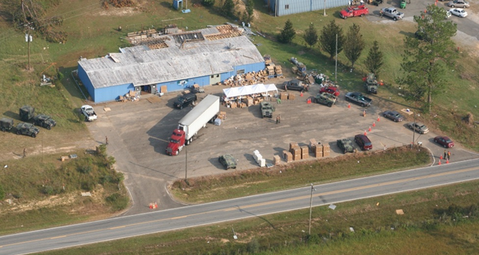

Loading Points

Example of a Complex CPOD Site Layout

Ensure that your community knows where to find the CPOD, what the distribution hours are, and what supplies are available.

You will also need to clearly identify who will be responsible for running the CPODs and direct-to-home deliveries. The EMD cannot be the only one responsible as that person will be extremely busy with many disaster response activities.

**Simple CPOD Operations**

During simple CPOD Operations, the CPOD Manager may be the only person on site, or he/she may have 2-3 people assisting with distribution of supplies. In general, for a simple CPOD would be 1 or 2 connex containers in a parking lot with manned distribution hours. Key responsibilities described below must still be completed:

1. Supply Management
   1. Tracking the amount of supplies available in storage on site
   2. Tracking the amount of supplies distributed
   3. Reporting the end of day supply inventory to the local EMD or other designated person
2. Safety/Health Management
   1. Maintaining safety of everybody on the site, to include the people picking up supplies
   2. Safely controlling the flow of traffic
   3. Adequate amount of shelter, food, water on site for daily operations
   4. Adequate emergency medical supplies on site
   5. Ensuring site security both during off-hours and during distribution hours
      1. Off-hours site security could be as simple as making sure the storage/staging container is properly locked at the end of the day
3. Personnel Management
   1. Maintaining manning rosters to make sure site personnel have the ability to take breaks as needed
   2. Rosters will also allow the EMD to know that the site will be adequately staffed for efficient distribution depending on the number of people coming to pick up supplies

**Complex CPOD Operations**

Complex CPOD operations, such as a food bank or a CPOD in a highly populated area or requiring more space for handling heavy vehicle traffic flows, would require more personnel to ensure efficient supply distribution. Below is a diagram of the personnel who would be needed to operation a more complex CPOD.

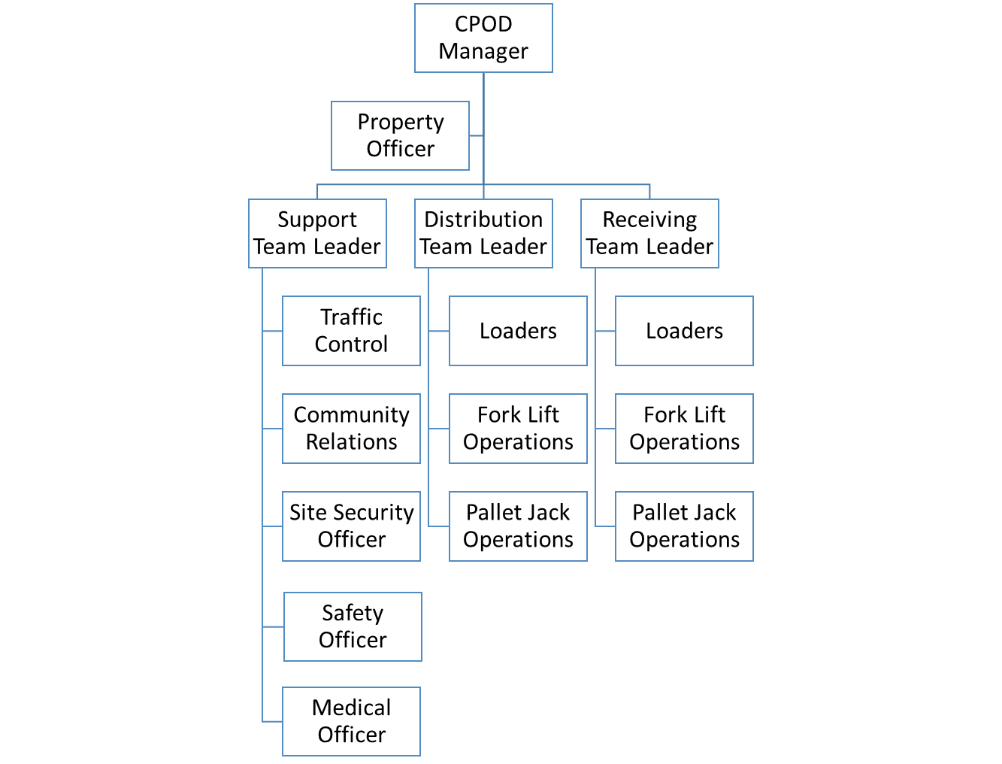

1. Emergency Management Director Responsibilities

The local EMD where the operational CPOD is located will maintain direct support and supervision for the CPOD Manager.

1. CPOD Manager

The CPOD Manager will be responsible for receiving all commodities that are transported from SLSA and signing for receipt of those supplies. They will maintain primary responsibility for coordination of distribution through the management of the CPOD Team. Additional responsibilities will include:

1. Identifying any equipment shortfalls at the site and reporting those shortfalls to the EMD who will submit request to the Logistics Sections of the SEOC.
2. Ensuring effective distribution of commodities to impacted communities.
3. Coordinating with the local EMD, SEOC Logistics Section and SLSA Manager for upsizing/downsizing the CPOD and reception of supplies.
4. Ensuring all personnel at the distribution center act in a polite and courteous manner while serving municipal customers.
5. Reporting “burn rates” to the EMD who will submit report SLSA and SEOC and working to develop future commodity needs.
6. Ensuring that paramount importance is placed upon safety.
7. Planning for and initiating downsizing/deactivation of the CPOD.
8. Property Officer
9. Tracking all equipment and resources used during CPOD operations.
10. Ensures that all loaned resources (primarily non-perishable equipment) are properly maintained
11. Upon deactivation, ensures borrowed equipment cleaned and returned to the original owners.
12. Support Team

The Support Team supports the receiving and distribution teams by:

1. Maintaining traffic control
2. Providing community relations
3. Sustaining staff operations to include:
   1. Restrooms
   2. Break Areas
   3. Trash Removal
   4. Staff Feeding
   5. Establishing Shift Schedules
   6. Providing site security, safety, and medical support

The Support Team Staff consists of:

1. Support Team Leader

The Support Team Leader supervises all support operations and reports to the CPOD Manager. Additional duties include:

1. Ensuring equipment used on-site has been inspected, maintained, and used in a safe manner
2. Coordinating supply truck movement on site
3. Maintaining accountability of all commodities received, on hand, and distributed from the site.
4. Maintaining all paperwork relating to resource accountability and providing daily resource reports to the CPOD Manager
5. Oversees site security and coordinates with local law enforcement for assistance
6. Oversees site safety and medical assistance as needed and works with first responders during a medical emergency.
7. Traffic Controller
8. Manages the movement of vehicles through the POD, to include customer vehicles and tractor trailers.
9. Directly controls the movement of vehicles in the vehicle lane and oversees the safety of loaders on the vehicle line
10. Handles all issues with customer vehicles, such as breakdowns, with assistance from the Support Team Leader
11. Community Relations
12. Serves as the central point of contact for media and public relations on the site
13. Works with the SEOC’s Public Information Officer (PIO) to distribute public information (flyers, handouts, etc)
14. Site Security Officer
15. Responsible for securing the CPOD site and ensuring/maintaining good order.
16. Primary staff member that will work with angered or agitated customers.
17. Should be a law enforcement officer or an individual trained in security operations.
18. Safety Officer
19. Responsible for ensuring that all operations are conducted in a safe manner utilizing proper safety equipment and personal protective equipment (PPE) (such as eyewear, masks, gloves, safety vests, hearing protection, etc, as appropriate).
20. Should be familiar with OSHA safety regulations and is responsible for ensuring that adequate safety equipment and PPE is available at all times on site.
21. Medical Officer
22. Responsible for providing first aid and other first responder medical assistance until other emergency medical personnel arrive on scene. This person and any supporting medical staff should have current CPR and First Aid certifications.
23. Should be comfortable and experienced with providing first aid and working with other medical professionals.
24. Responsible for ensuring that adequate emergency medical, water, and food supplies are available at all times on the site.
25. Distribution Team

The Distribution Team conducts loading operations. The Distribution team supports the loading line by:

1. Conducting customer commodity loading
2. Resupplying loading points
3. Assisting the Support Team with trash removal.

The Distribution Team consists of:

1. The Distribution Team Leader

The Distribution Team Leader supervises all loading and sustainment operations including:

1. Loading of supplies into customer vehicles
2. Ensuring the Loading Line has adequate supplies by coordinating with the Support and Receiving Team Leaders
3. Reports to the CPOD Manager
4. Loaders
5. Loading set quantities of supplies into customer vehicles
6. Coordinate with the Receiving Team through the Distribution Team Leader for resupply of the loading line
7. Fork Lift Operations
8. Manages the movement of pallets to and from the resupply vehicle(s), including resupplying the loading line.
9. **NOTE:** All Fork Lift Operators **MUST** be qualified in order to operate the equipment.
10. Pallet Jack Operations
11. Responsible for the movement of pallets from the loading line and moving empty pallets to the receiving location.
12. Must be familiar with the equipment and conduct movement safely.
13. Receiving Team

The Receiving Team conducts unloading and resupplying for the Distribution team. The receiving team supports the loading line by:

1. Conducting receiving operations from LSA deliveries.
2. Resupplying loading points
3. Unloading bulk commodities
4. Assisting the Support Team with trash removal

The Receiving Team consists of:

1. The Receiving Team Leader

The Receiving Team Leader supervises all unloading and sustainment operations including:

1. Unloading of supplies from LSA deliveries
2. Ensuring the Loading Line has adequate supplies by coordinating with the Distribution Team Leader
3. Conducting resupply operations including downloading commodities and resupplying the loading line
4. Reports to the CPOD Manager
5. Loaders
6. Unloading bulk commodities from LSA delivery vehicles.
7. Coordinate with the Receiving Team Leader for resupply of the loading line
8. Fork Lift Operations
9. Manages the movement of pallets to and from the resupply vehicle(s), including resupplying the loading line.
10. **NOTE:** All Fork Lift Operators **MUST** be qualified in order to operate the equipment.
11. Pallet Jack Operations
12. Responsible for the movement of pallets to the loading line.
13. Must be familiar with the equipment and conduct movement safely.

## Closing it down

Once the need for a CPOD or other distribution actions are no longer needed, the community needs to have a plan for deactivating the CPODs and ending distribution actions.

**Deactivation Checklist**

* Gain approval from EMD to begin deactivation procedures
* Conduct a full inventory of all the equipment used
  + Include equipment that was contracted or volunteered
* Clean all equipment and return it to its original owners
* Conduct a full inventory of leftover supplies
  + Properly discard items that are past their shelf life
  + Properly store and secure all other items for use during the next incident
* Ensure all paid personnel’s timesheets are completed properly and submitted
* Track all volunteer personnel hours for submission to the volunteer agencies
* Make sure the distribution site has been cleaned up, especially if it is leased or borrowed from another agency/community